**UNIVERSITY OF HYDERABAD,**

**TELANGANA ,500046**

**Project Report on**

**“Student Feedback Sentiment Analysis”(2024-26)**

*The Report submitted to*

### School of Management Studies

**Subject: Essentials Of Business Analytics**

***Submitted By Group Number 4:***

**Boddapati Kanchana : 24MBMB02**

**Nikita Bharti: 24MBMB18**

**Miriyala Akhil : 24MBMB37**

**Priya Saini: 24MBMB34**

**Dharamsoth Harish Naik: 24MBMB33**

**Balakrishna : 24MBMB38**

***Under the guidance of***

**Dr. C. Ganesh Kumar (Assistant Professor)**

**TABLE OF CONTENTS**

1. Declaration
2. Acknowledgment
3. University of Hyderabad
4. Research Study Introduction
5. Objectives
6. Data Analysis
7. Data Interpretation
8. Significance of Study
9. Limitations
10. Suggestions
11. Conclusion and References

**Declaration**

We, the undersigned, hereby declare that this project titled “Student Sentiment Feedback Analysis ” of Students at the University of Hyderabad is an original work carried out by our team as part of the academic requirements of the MBA program in Business Analytics at the University of Hyderabad.

We are: **Boddapati Kanchana (Roll No: 24MBMB02), Nikita Bharti (Roll No: 24MBMB18), Priya Saini (Roll No.: 24MBMB34), Miriyala Akhil (Roll No: 24MBMB37), Balakrishna (Roll No: 24MBMB38), and Dharamsoth Harish Naik (Roll No: 24MBMB33).**

The objective of this project is to analyze student feedback regarding various facilities provided by the University of Hyderabad, including the library, hostel facilities, transportation, sports, healthcare, and the placement cell, and to conduct statistical operations to understand sentiment trends. The insights derived from this analysis aim to support improvements in student satisfaction and enhance the quality of services provided by the university.

For this analysis, we collected feedback from a sample of 30 students using a Google Forms questionnaire consisting of 25 questions. We applied descriptive and predictive analytics to interpret the feedback and identify sentiment patterns. Data was gathered ethically, with students' privacy respected and consent obtained for the use of their responses in this analysis.

We extend our sincere gratitude to Ganesh Sir for his invaluable guidance throughout the project. His support and insights have been instrumental in the successful completion of our work.

We certify that this document is a true representation of our findings and analysis, completed with utmost integrity and dedication.

**Acknowledgement**

We would like to express our heartfelt gratitude to Dr. C. Ganesh Sir for his invaluable guidance, support, and encouragement throughout our project, “Student Sentiment Feedback Analysis of Students at the University of Hyderabad.” His expertise and insightful feedback have been crucial in refining our approach and achieving our objectives.

We also extend our thanks to our classmates and fellow students at the University of Hyderabad who participated in the survey, contributing their honest feedback and experiences. Their responses have been essential in helping us gain meaningful insights into the university’s facilities.

We are grateful to the University of Hyderabad’s School of Management Studies for providing us with access to resources, including the use of platforms like Google Forms and data analysis software, which have been instrumental in conducting this research effectively.

Our sincere appreciation also goes to each team member for their dedication and collaboration. This project has not only allowed us to contribute to the university community but has also strengthened our analytical and teamwork skills, preparing us for future data-driven projects.

**INTRODUCTION**



The University of Hyderabad (UOH), established in 1974, is a premier institution of post-graduate teaching and research in India. Known for its interdisciplinary approach, it offers over 150 programs across 12 schools, ranging from sciences, social sciences, and humanities to arts, management, and engineering. The university has consistently ranked among the top institutions in India, thanks to its strong emphasis on research, high-quality faculty, and diverse student body.

Throughout its history, UOH has developed a reputation for being student-centric, with policies promoting academic excellence and inclusivity. The campus is also known for its green and spacious environment, hosting a vibrant community of students and researchers. In recent years, UOH has embraced digital technologies for learning and administration, enhancing student experiences with online resources and digital libraries.

The University of Hyderabad (UOH) provides comprehensive facilities for students and staff, creating an environment conducive to academic, professional, and personal growth. Here's a summary of these facilities:

**1. Library Facilities**

• The Indira Gandhi Memorial Library is a state-of-the-art facility with over 4 lakh volumes, including books, journals, and electronic resources.

• The library provides access to various online databases, e-books, and research journals through its digital resources.

• There are specialized reading rooms, computer labs, and a digital library section to support students and faculty.

**2. Hostel Facilities**

• UOH offers on-campus hostel accommodations with separate hostels for male and female students.

• Hostels are well-equipped with basic amenities, including Wi-Fi, common rooms, dining areas, and security.

• There are facilities for recreational activities within the hostels, creating a comfortable living environment.

**3. Transportation Facilities**

• The university operates a shuttle bus service connecting the campus with major city areas, making it easier for students and staff to commute.

• Bicycles are also available on campus to promote eco-friendly transportation.

• UOH has well-maintained roads, parking spaces, and pedestrian pathways within the campus for safe and convenient mobility.

**4. Health Care Facilities**

• The university has a Health Centre that offers primary healthcare services to students, staff, and faculty.

• Services include consultations, emergency care, and a pharmacy, with specialized doctors available on certain days.

• The health center also organizes wellness camps, vaccination drives, and mental health counseling services.

**5. Placement Facilities**

• UOH has a dedicated Placement Cell that coordinates recruitment and internship opportunities for students across departments.

• The Placement Cell regularly organizes workshops, resume-building sessions, and mock interviews to prepare students.

• Collaborations with various companies, industries, and research institutions help bring ample placement opportunities on campus.

**6. Sports Facilities**

**1. Outdoor Sports Facilities**

**• Cricket Ground:** UOH has a well-maintained cricket field that hosts university tournaments and is available for students to practice.

**• Football Field:** There’s a dedicated football ground with sufficient space for regular matches and practice sessions.

**• Hockey Field:** The university also offers a hockey field for enthusiasts and team practices.

**• Tennis Courts:** Multiple tennis courts are available, catering to both recreational and competitive play.

**• Volleyball and Basketball Courts:** Outdoor courts for volleyball and basketball are accessible for students and teams.

**2. Indoor Sports Complex**

**• Badminton Courts:** The indoor complex features badminton courts with the necessary setup for regular practice and tournaments.

**• Table Tennis:** Table tennis facilities are available within the indoor sports area.

**• Gymnasium:** The gym is well-equipped with weightlifting and fitness machines for general fitness.

**• Chess and Carrom Boards:** Indoor board games like chess and carrom are also available, supporting recreational activities and intellectual development.

**Number of Students and Departments**

• The University of Hyderabad has a diverse student body across different departments including Sciences, Social Sciences, Humanities, Management, and Engineering.

• Approximately 5,000 to 6,000 students are enrolled across undergraduate, postgraduate, and Ph.D. programs in various departments.

• Departments include Physics, Chemistry, Mathematics, Economics, English, Sociology, and more, each with specialized faculty and research facilities.

These resources contribute to the University of Hyderabad’s reputation as one of India's premier higher education institutions.

**Objectives**

**The objective of this project is to analyze student feedback regarding various facilities provided by the University of Hyderabad, including the library, hostel facilities, transportation, sports, healthcare, and the placement cell. Specifically, we aim to:**

**1.Identify Key Sentiments**: Determine levels of student satisfaction and dissatisfaction with each facility, highlighting areas that meet or fall short of expectations.

**2. Assess Impact of Facilities**: Examine how various facilities influence overall student experiences and academic performance, providing insights into which services are deemed most valuable.

**3. Provide Actionable Recommendations**: Offer practical suggestions for improvements based on the analysis, aiming to enhance student satisfaction and the quality of services provided by the university.

**4. Support Data-Driven Decision Making**: Equip university administration with insights that can inform policy decisions and strategic planning regarding facility management and student services.

**5. Enhance Student Welfare**: Contribute to ongoing efforts to improve student welfare by fostering an environment where student feedback is valued and acted upon

**Research Study Introduction**

Understanding student sentiment is essential for any educational institution committed to fostering a positive, supportive environment. This study aims to analyze and interpret student feedback on six critical facilities within the university: the library, hostel mess, transportation services, sports facilities, health center, and placement services. By examining sentiments expressed in feedback, we hope to uncover insights into students’ experiences, preferences, and areas of concern.

**1. Library:** A university’s library plays a fundamental role in academic life, providing essential resources, study spaces, and access to knowledge. This study examines how students perceive the library in terms of availability, accessibility, and resource quality.

**2. Hostel Mess:** The quality of food and service in hostel messes significantly impacts student satisfaction. Here, we investigate student sentiments about food quality, menu variety, cleanliness, and overall dining experience in the hostel mess.

**3. Transportation Services:** Efficient transportation is crucial for students who live off-campus or commute. This section explores students' views on the frequency, accessibility, and punctuality of university transportation services.

**4. Sports Facilities:** Physical fitness and recreation play an important role in student life. We analyze feedback on sports facilities to understand students’ perspectives on the quality, maintenance, and availability of sports equipment and spaces.

**5. Health Center:** A well-equipped health center is essential to provide students with medical support and well-being services. This study includes students' feedback on the availability, quality, and responsiveness of health services offered on campus.

**6. Placement Services:** Placement services are a vital resource for students transitioning from academics to professional careers. We examine sentiments on placement assistance, guidance, and the effectiveness of university efforts in securing job opportunities for students.

In this study, we formed into a group of 6 students and each one of us has taken one area for study such as library, hostel, transportation, placement, healthcare etc. Each one of us made 5 to 6 questions on each area in order to study the Student Feedback. Later we prepared a questionnaire consisting of 25 questions collectively for all the areas namely sections. Later we distributed among the students of university of Hyderabad across different branches and collected 30 responses overall.

The biggest limitation of our study is the time and sample size. Whatever the conclusions that we are going to draw from these insights is only applicable for a small sample and cannot be applicable to the large population.

By collecting and analyzing feedback, this study seeks to provide actionable insights for university administrators to improve the quality of these facilities and, consequently, enhance overall student satisfaction.

**Data Analysis**

**Techniques used in Data analysis**

**Descriptive Statistics**

**1. Mean:**

The mean, or average, is the sum of all values divided by the number of values. It provides a central value, indicating where the "center" of the data lies. It is useful for understanding the

overall level or tendency in the dataset.

**2. Standard Error:**

Standard error measures the accuracy of the sample mean by estimating the variability of the mean if multiple samples were taken. It is calculated by dividing the standard deviation by the square root of the sample size. Lower standard error values indicate that the sample mean is a more accurate estimate of the population mean.

**3. Median:**

The median is the middle value of a data set when it is arranged in ascending or descending order. It represents the point at which half the values are above and half are below. The median is less sensitive to extreme values (outliers) than the mean.

**4. Mode:**

The mode is the value that appears most frequently in a data set. It is useful for identifying the most common or popular response, especially in categorical or discrete data.

**5. Standard Deviation:**

Standard deviation is a measure of the dispersion or spread of values around the mean. A high standard deviation indicates that data points are spread out over a wider range, while a low standard deviation means they are closer to the mean.

**6. Sample Variance:**

Variance is the square of the standard deviation and indicates the degree of spread in the data. Sample variance is used when calculating the variance from a sample of a population. Like standard deviation, it provides insight into the variability within the dataset.

**7. Kurtosis:**

Kurtosis measures the "tailedness" or the presence of outliers in a data distribution. High kurtosis indicates heavy tails and more outliers, while low kurtosis indicates light tails and fewer outliers. It helps in understanding the extremeness of data points compared to a normal distribution.

**8. Skewness:**

Skewness indicates the asymmetry of the data distribution. Positive skewness means data is skewed to the right (more values on the left), and negative skewness means data is skewed to the left (more values on the right). It helps in understanding whether data is evenly distributed around the mean or if it leans towards one side.

**9. Range:**

The range is the difference between the maximum and minimum values in the dataset. It provides a quick view of the spread of data. However, it is sensitive to outliers and may not fully represent the variability if there are extreme values.

**10. Minimum:**

The minimum is the smallest value in the dataset. It gives insight into the lower boundary of the data and is useful in understanding the extent or scope of values in a set**.**

**11. Maximum:**

The maximum is the largest value in the dataset, representing the upper boundary. It is useful in identifying the highest observed value in the data**.**

**12. Sum:**

The sum is the total of all values in the dataset. This can be useful for financial or aggregate data where the total value matters.

**13. Count:**

The count is the total number of observations in the dataset. It is used to measure the sample size, which is essential for calculating other statistics like the mean and standard error.

These techniques provide a comprehensive overview of the data’s central tendency, spread, and distribution shape, helping in the analysis and interpretation of patterns, trends, and anomalies in the dataset.

**Charts**

**1. Line Chart**

Line charts are used to show trends or changes across categories. In the case of library facilities and sports, line charts depict satisfaction levels across different effectiveness ratings, separated by gender. This helps in easily spotting trends, such as whether satisfaction levels are improving or declining across different categories.

**2. Bar Chart**

The bar chart is useful for comparing quantities across categories. Here, it shows the distribution of student ratings for health center services, separated by gender. Bar charts allow for quick comparison of values, helping identify which rating category is most common among male and female students.

**3. Clustered Bar Chart**

Clustered bar charts allow comparison within and between categories. In the mess food chart, ratings are grouped by gender and location (North and South), showing how different groups perceive mess food quality. This type of chart is useful for multi-variable comparison, as it presents data for multiple categories in one view.

**4. Area Chart**

Area charts highlight the cumulative values over a range, emphasizing total quantities while also showing category breakdowns. In the placement services chart, it helps illustrate the distribution of ratings (from Excellent to Poor) and the differences between male and female responses. Area charts are effective in showing volume or proportions within different segments.

**5. Stacked Bar Chart**

Stacked bar charts are used to display part-to-whole relationships within different groups. The hostel location chart shows the distribution of male and female students in North and South hostels, indicating the relative proportion of each gender in both locations. This provides insight into the gender composition without needing separate bars for each group.

**6. Horizontal Stacked Bar Chart (**

Horizontal stacked bar charts are similar to stacked bar charts but are oriented horizontally. In this case, the chart shows the availability of transport facilities on both campuses. It provides a visual breakdown of "Yes" and "No" responses, helping to see the proportion of students with access to transport facilities in an easily interpretable format.

**Pivot Tables**

Pivot tables are powerful data summarization tools commonly used in spreadsheet applications like Microsoft Excel and Google Sheets. They allow users to organize, filter, and summarize large data sets to identify trends and insights quickly. With pivot tables, users can transform raw data by grouping it into categories, calculating subtotals, and applying calculations such as sums, averages, and counts. Pivot tables are highly customizable, allowing for rearranging rows, columns, and fields dynamically to view data from different perspectives. This flexibility makes pivot tables essential for data analysis, reporting, and visualization, especially in business and finance.

**Interactive Dashboard**

An interactive dashboard in Excel is a powerful tool that provides dynamic insights and allows users to analyze data visually. It combines various elements like charts, tables, and slicers to present key metrics and trends in a visually appealing, user-friendly interface. By using interactive components such as dropdowns, buttons, and filters, users can customize the view to focus on specific data points, time frames, or categories. This flexibility makes it easier to track performance, identify patterns, and make data-driven decisions in real time, making it ideal for business analytics, reporting, and project management.

**Predictive / Inferential Statistics**

**Chi-Square – Independence of Association**

The Chi-Square test for independence of association is a statistical method used to determine if there is a significant association between two categorical variables. It compares the observed frequencies of occurrences in each category with the expected frequencies if the variables were independent. The formula calculates a Chi-Square statistic, which is then evaluated against a critical value from the Chi-Square distribution table to check for significance. A high Chi-Square value indicates a potential association between the variables. This test is widely used in fields like social sciences, marketing, and biology for hypothesis testing.

**Independent Sample T Test**

An independent samples test, often called an independent samples t-test, is a statistical method used to compare the means of two independent groups to determine if there is a significant difference between them. It assumes that each sample is drawn from a normally distributed population with equal variances. This test is commonly used in experiments where two separate groups are compared, such as comparing test scores between two different classes or response times between two age groups.

**Correlation**

Correlation is a statistical measure that describes the extent to which two variables move in relation to each other. It ranges from -1 to +1, where +1 indicates a perfect positive relationship, -1 indicates a perfect negative relationship, and 0 implies no correlation. Positive correlation means that as one variable increases, the other tends to increase as well, while negative correlation means that as one variable increases, the other tends to decrease. Correlation is widely used in finance, economics, and research to identify relationships and patterns in data.

This is the explanation of all the 6 different techniques that we have used in interpreting the data. The following section will give a brief information on the insights that are drawn from these techniques.

**Data Interpretation**

**Descriptive Statistics**

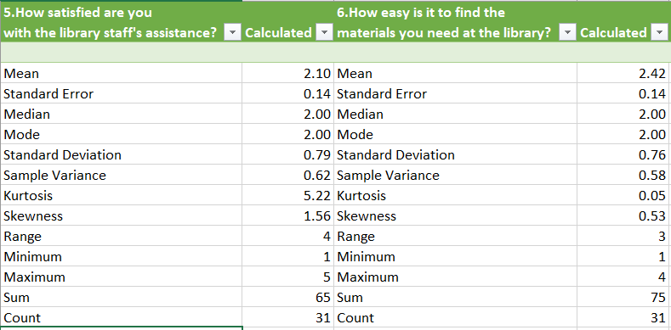

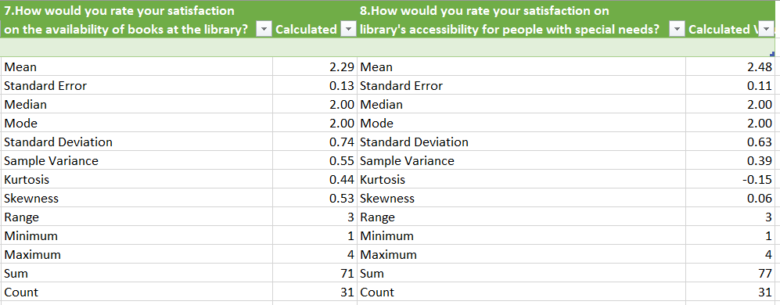

The table displays descriptive statistics for four questions related to library services, measured on a satisfaction scale. Here’s a breakdown of insights based on each question:

**1. Satisfaction with Library Staff’s Assistance**

**• Mean:** 2.10, suggesting relatively low satisfaction on a scale where higher values indicate better satisfaction.

**• Median:** 2.00, which aligns with the mean, indicating a balanced distribution without extreme outliers.

**• Skewness:** 0.53, indicating slight positive skewness. Most ratings are low, but a few respondents rated assistance higher.

**• Kurtosis:** 1.56, suggesting a slightly peaked distribution compared to a normal distribution, possibly with many respondents giving similar responses.

**• Range:** 3 (between 1 and 4), showing limited variation in responses.

**2. Ease of Finding Materials**

**• Mean:** 2.42, indicating slightly better satisfaction than library staff assistance.

**• Median:** 2.00, showing that most responses are around the lower satisfaction side.

**• Skewness:** 0.08, almost neutral, meaning responses are evenly distributed.

**• Kurtosis:** 0.35, indicating a flatter distribution, implying that responses might be more spread out across the scale.

**3. Satisfaction with Book Availability**

**• Mean:** 2.29, showing moderate satisfaction, similar to the previous aspects.

**• Median:** 2.00, indicating most responses are around the middle range.

**• Skewness:** 0.39, showing a mild positive skew, where more respondents are on the lower end of satisfaction.

**• Kurtosis:** -0.35, showing a flatter than normal distribution, with diverse responses.

**4. Accessibility for People with Special Needs**

**• Mean:** 2.48, the highest among all questions, indicating relative satisfaction.

**• Median:** 2.00, with responses mainly in the lower to middle range.

**• Skewness:** -0.10, a slight negative skew, indicating that slightly more respondents are giving higher ratings.

**• Kurtosis:** -0.65, indicating a flatter distribution, suggesting that opinions are more varied on this topic.

**General Observations:**

**• Overall Satisfaction:** The mean scores are generally low across all aspects, indicating that users are somewhat dissatisfied with library services.

**• Skewness and Kurtosis Patterns:** Most responses are slightly positively skewed, suggesting that while a majority may feel neutral or slightly dissatisfied, some users have more favorable views.

**• Consistency:** The medians are consistently at 2, showing that a large proportion of respondents rate satisfaction in the lower to mid-range.

These findings suggest areas for improvement, especially in enhancing user support and accessibility to meet a wider range of user needs effectively.

**Pivot Table**

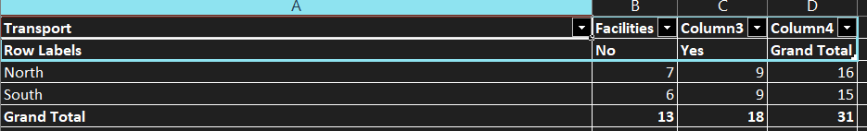

**1. Transport Facilities Overview:**

• The table summarizes data related to transport facilities for two regions: North and South.

• The facilities are categorized under "Yes" (facility available) and "No" (facility not available).

**2. Regional Breakdown:**

**• North Region:**

• Has 7 units without facilities and 9 units with facilities.

• The total number of units in the North region is 16.

**• South Region:**

• Has 6 units without facilities and 9 units with facilities.

• The total number of units in the South region is 15.

**3. Facility Availability Analysis:**

• Out of 31 total units (both regions combined), 18 units have transport facilities, while 13 units do not.

• This means approximately 58% of the units have transport facilities available, whereas 42% do not.

**4. Comparison Between Regions:**

• Both regions have an equal number (9) of units with facilities.

• The North region has slightly more units overall (16) than the South (15), with a marginally higher count of units without facilities in the North.

**5. General Insight:**

• The overall transport facility coverage seems balanced between the regions.

• However, there’s still a significant proportion (42%) of units without transport facilities, indicating a potential area for improvement, especially if transport access is critical for operations.

This analysis provides a quick snapshot of transport facility distribution and highlights potential areas to focus on for resource allocation or improvement.

**Dashboard**

1. **Library Facility:**

The line chart displays student satisfaction with library facilities, categorized by gender.Female students show a higher level of satisfaction as the chart moves towards the "Satisfied" section, whereas male satisfaction rises consistently but at a lower rate. This suggests that females tend to have a slightly better perception of the library facilities than males.

**2. Health Center:**

The bar chart illustrates the effectiveness of health center services as rated by students.Both male and female students rated the health center as "Average" or "Good" most frequently, with fewer students rating it as "Excellent" or "Poor." This indicates that while most students find the health center adequate, there may be room for improvement to achieve higher satisfaction levels.

**3. Sports Facilities:**

The line chart for sports facilities shows fluctuating ratings across effectiveness levels, with some extreme variations.Both male and female students display a mix of opinions, indicating that views on sports facilities are quite varied. This inconsistency suggests that sports facilities may need a more uniform standard of quality or that students have diverse needs in this area.

**4. Mess Food:**

The clustered bar chart shows satisfaction with mess food, broken down by gender and location (North and South)."Neutral" responses are the most common across all categories, with a notable percentage of students in both locations feeling "Fully Dissatisfied.”. This indicates that mess food could be a concern for many students, particularly in terms of quality and variety, and may require improvement.

**5. Placement Services:**

The area chart illustrates student perceptions of placement services based on different rating categories from "Excellent" to "Poor "Most students rated placement services as "Good," with fewer students selecting "Excellent" or "Poor."The data suggests that while placement services are generally seen as satisfactory, there may be potential to enhance services to achieve higher ratings.

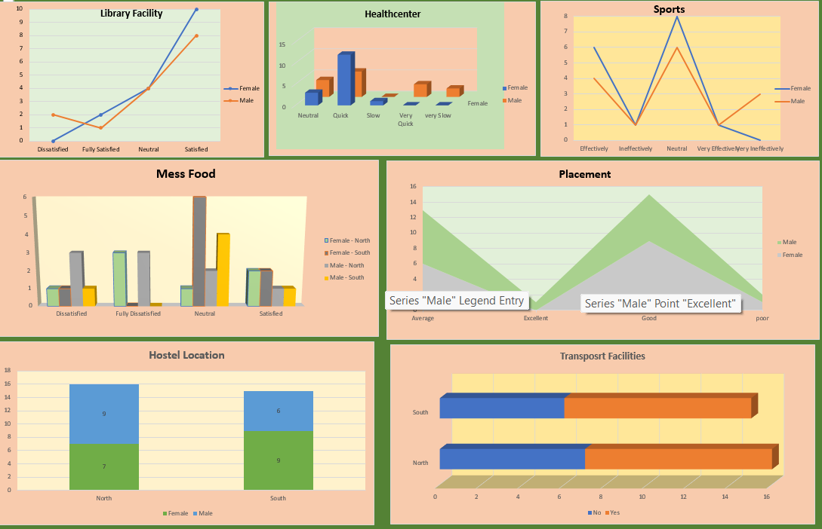

**Chi Square Test**

**Objective:** To find out the significant association between the quality of food with respect to Hostel Location namely North and South.

**Data Nature**

|  |  |  |
| --- | --- | --- |
| Type Of Technique | Dependent Variable – Target / Output Variable | Independent Variable - Input Variable |
| Chi Square – Independence of Association | One Category – quality of food | One Category – hostel location |

**Formation of Hypothesis**

**Null Hypothesis:** There is no significant association between quality of food and hostel location.

**Alternative Hypothesis:** There is significant difference between quality of food and hostel location.

**Estimation Process using Excel**

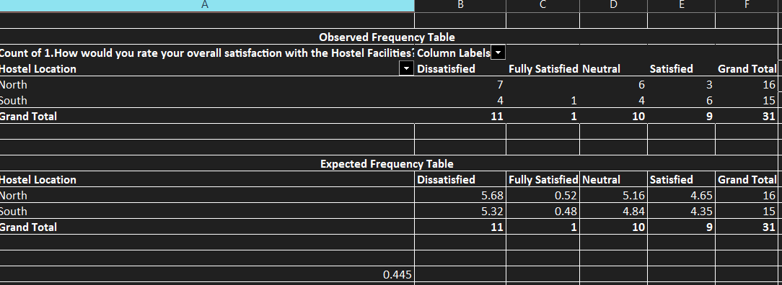

**Statistical Interpretation**

The P Value of 0.445 is greater than the 0.05 level of significance. So it falls in acceptance region. Therefore, the null hypothesis is accepted. Hence, there is no significance association between quality of food and the hostel location.

**Managerial Decision Making**

**1. Standardize Quality Control Processes:** Since there is no difference in food quality across locations, it indicates that existing quality control measures are effective. Managers should focus on maintaining these processes across all locations to sustain this consistency.

**2. Focus on Other Factors Affecting Satisfaction:** As food quality isn't influenced by location, managers could explore other factors that might impact satisfaction, like menu variety, meal times, or portion sizes. Conducting surveys or focus groups could provide further insights into student preferences.

**3. Optimize Resource Allocation:** Given that location does not impact food quality, resources could be allocated based on other needs. For example, instead of investing heavily in equipment or facilities based on hostel location, funds can be directed towards improving ingredients, cooking staff skills, or overall dining environment.

**4. Centralize Food Preparation (if feasible):** If food quality remains consistent across locations, centralizing food preparation for distribution could help manage costs without sacrificing quality. Centralization may allow for bulk purchasing and streamlined logistics.

**5. Reinforce Positive Branding:** Use this information to reinforce the message that food quality is reliably high regardless of location. This can enhance the reputation of the hostel facilities and build trust among students and parents.

**Independent Sample T Test**

**Objective:** To find out the significance difference in gender with respect to finding the necessary books / materials at the library.

**Data Nature**

|  |  |  |
| --- | --- | --- |
| Type of Technique | Dependent / target / output Variable | Independent / Input Variable |
| Independent Sample T Test | Numeric – Finding the books at Library | One Category – Gender |

**Formulation of Hypothesis**

**Null Hypothesis:** There is no significant difference in gender with respect to finding the books at library.

**Alternative Hypothesis:** There is significant difference in gender with respect to finding the books at library.

**Estimation Process in Excel**

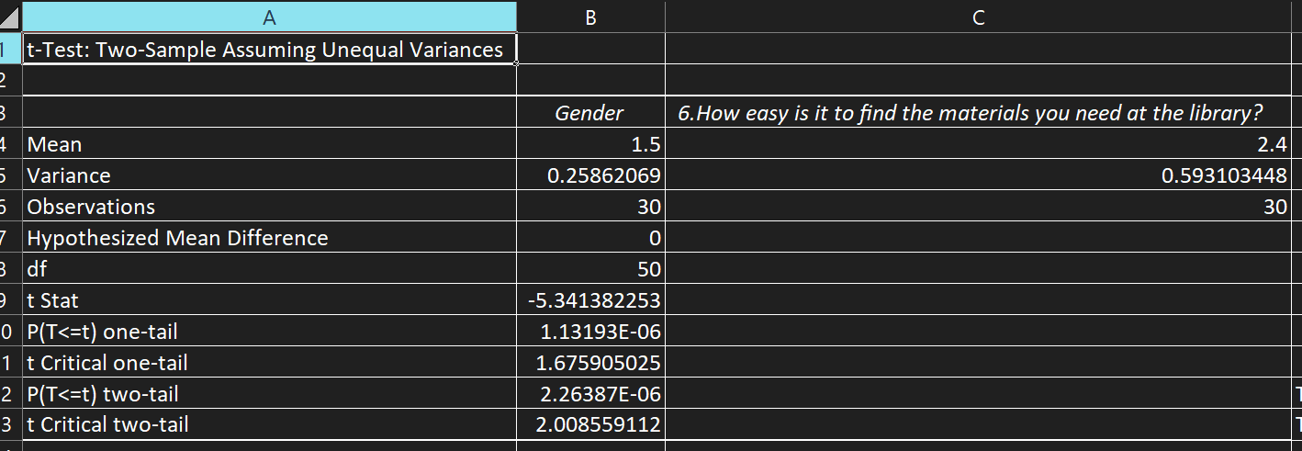

**Statistical Interpretation**

The P Value of 2.26 is greater than the 0.05 level of significance. It falls in acceptance regeion and the null hypothesis is accepted at 95% confidence level. Hence. There is no significance difference in gender with respect to finding the necessary books at the library.

**Managerial Decision Making**

**1. Standardized Assistance Programs:** Since there’s no gender difference, focus on creating standardized support services that cater to all students. Consider implementing universal resources like maps, signage, or digital locators that benefit all users equally.

**2. Enhanced Digital Solutions:** If both male and female students find the library resources similarly accessible, consider developing a user-friendly mobile app or an online catalog that can help everyone locate books more efficiently. This approach ensures equal support for all demographics without gender-specific tailoring.

**3. Training and Awareness Programs:** Library staff could be trained to understand and meet diverse needs effectively. By focusing on user-experience feedback, they can guide students uniformly and address general difficulties that might affect different users equally, such as unclear categorization or challenging navigation.

**4. Improve Overall User Experience:** If gender doesn’t influence book-finding ease, focus on other potential user pain points, such as physical accessibility, layout clarity, or resource allocation. Conduct surveys to gather feedback on these areas and refine the library layout or categorization accordingly.

**5. Assess and Segment Based on Other Factors:** Investigate other variables, like age or subject area, that might impact students’ ability to locate resources. This segmented approach can allow for more tailored improvements that enhance overall user experience across different user groups.

**Correlation**

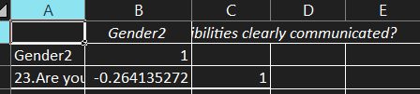

**1. Gender and Responsibilities Communicated (Question 23):** The correlation coefficient between "Gender2" and the response to "Are your responsibilities clearly communicated?" is approximately -0.264.

**2. Interpreting the Correlation:**

• A correlation of -0.264 indicates a weak negative relationship between gender and the clarity of communicated responsibilities. This suggests that as gender changes (likely from male to female, depending on encoding), there is a slight tendency for responses about clarity of communication to change inversely.

• However, this correlation is weak and close to zero, meaning that gender is not a strong predictor of the clarity of responsibility communication within the placement cell. In practical terms, gender does not appear to play a significant role in influencing whether responsibilities are clearly communicated.

**Significance of Study**

This study holds substantial importance for university administrators, students, and stakeholders, as it provides a nuanced understanding of student satisfaction across key areas critical to campus life. By examining sentiments related to the library, hostel mess, transportation, sports facilities, health center, and placement services, the study offers the following key benefits:

**1. Enhanced Student Experience:** Understanding student feedback allows theuniversity to prioritize and improve services that directly impact student life. Addressing students' needs and concerns can lead to a more positive, enriching campus experience, increasing both academic success and personal well-being.

**2. Data-Driven Decision Making:** This study uses sentiment analysis, providing administrators with actionable insights based on student opinions. Rather than making changes based solely on assumptions, data-driven decisions help in allocating resources effectively, ensuring that improvements are targeted where they are most needed.

**3. Boost in Institutional Reputation:** By improving facilities based on student feedback, the university can enhance its reputation for being responsive to students’ needs. This, in turn, can help attract prospective students, boost student retention rates, and improve overall student satisfaction rankings, positioning the university as a student-centered institution

**5. Long-term Planning and Development:** The insights from this study can be used to inform the university's long-term development strategies. By understanding ongoing and future needs, the university can better plan facility upgrades, expansions, and initiatives that align with student expectations**.**

In sum, this study not only helps identify current challenges but also sets the foundation for creating a more responsive, student-centered educational environment. Through continuous improvements based on feedback, the university can ensure that it meets the evolving needs of its student body, supporting their academic journey and overall growth.

**Limitations**

**1. Data Quality and Reliability:** The quality of data used for sentiment analysis significantly impacts the accuracy of the results. Student feedback may contain slang, abbreviations, spelling errors, and inconsistencies, especially in informal surveys or open-ended responses. Additionally, some feedback may be ambiguous or sarcastic, which can be challenging for automated sentiment analysis tools to interpret accurately. These factors can introduce noise into the dataset, making it harder to achieve reliable insights. Ensuring data quality may require pre-processing and cleaning, which can be time-consuming and may still not eliminate all inaccuracies.

**2. Limited Sample Size:** If the analysis only includes feedback from a limited group of students, the results may not represent the entire university population’s sentiments. Students from different departments, years of study, or demographic backgrounds may have varied experiences and perspectives. A small sample size can lead to sampling bias, where the analysis reflects only a subset of opinions rather than capturing the diversity of the student body. For a more representative analysis, a larger and more diverse sample of feedback is ideal, but it may be challenging to collect feedback from a wide range of students.

**3. Privacy and Ethical Concerns:** Collecting and analyzing student feedback must be done carefully to protect privacy and comply with ethical standards. Student feedback may contain personally identifiable information (PII) or sensitive opinions, so it’s crucial to anonymize data to prevent any misuse of personal information. Additionally, obtaining informed consent from students is essential, as they should know how their feedback will be used. Mishandling this data can lead to ethical and legal issues, compromising students' trust in the institution and potentially deterring them from providing honest feedback.

**4. Time Sensitive Sentiment Variation:** Student sentiments are often influenced by time-sensitive factors such as recent events, academic stress during exams, or major policy changes at the university. Sentiment analysis that doesn’t account for these temporal variations might overlook the reason behind shifts in sentiment. For example, a spike in negative feedback could be linked to midterm exams or a particular administrative decision. To gain more relevant insights, it may be necessary to track and analyze feedback over time, noting when the data was collected to identify trends and any correlation with specific events.

**5. Categorization of Sentiment Categories:** Sentiment analysis tools typically categorize feedback as positive, negative, or neutral, which may not capture the full range of emotions students experience. Students might express feelings like frustration, confusion, enthusiasm, or apathy, which don’t fit neatly into these three categories. By oversimplifying sentiments, the analysis might miss nuanced feedback, such as students who feel positively about certain aspects but have specific frustrations with others. Expanding the categories or using more sophisticated emotion detection models can help capture a broader spectrum of student emotions.

**Suggestions**

**1. Identifying Key Areas of Improvement:** By analyzing the sentiment data, we can pinpoint specific aspects of each facility where students feel improvements are necessary. For instance, if students express frequent dissatisfaction with transportation punctuality, this would be a high-priority area for intervention.

**2. Enhanced Resource Allocation:** The study can guide resource allocation by highlighting which facilities are perceived as lacking. For example, if the health center receives low satisfaction scores related to wait times, additional resources may be allocated to increase staffing during peak hours.

**3. Actionable Feedback for the Hostel Mess:** varied menu options. Addressing these concerns can lead to improved satisfaction with dining services and potentially reduce food waste.

**4. Improving Student Well-being through Sports and Health Facilities:** Positive sentiment in sports and health facilities often correlates with improved mental and physical well-being. Any negative feedback could indicate that these areas need enhancements, such as updated equipment, better maintenance, or increased availability of healthcare services.

**5. Boosting Placement Satisfaction:** By addressing student feedback regarding placement services, such as providing more personalized career guidance or offering workshops on interview preparation, the university can increase student confidence in career readiness and improve overall satisfaction with the placement process.

**Conclusion**

In conclusion, our analysis of student sentiment feedback across various aspects of campus life—including the health center, placement services, sports facilities, library resources, mess food quality, hostel amenities, and bus route accessibility—offers valuable insights into areas where the institution excels and where there is room for improvement. By examining these factors, we have gained a clearer understanding of students' perceptions and overall satisfaction levels. This feedback serves as a guide for targeted enhancements, helping us create a more supportive and enriching environment that addresses student needs and fosters a positive academic experience. Continuous monitoring and responsiveness to student sentiment will be essential in maintaining and improving student satisfaction and campus life quality.

References

<https://uohyd.ac.in>

https://www.shiksha.com › Colleges in Hyderabad

https://en.wikipedia.org › wiki › University_of_Hyderabad

<https://github.com/Pro-1210/Student-feedback-sentiment-analysis>

<https://www.mdpi.com/2076-3417/11/9/3986>